**Supporting information of**

**Design of novel double-layer wrapped ammonium polyphosphate and its application in aging resistance and flame retardant crosslinked polyethylene composites**

Pengfei Jia, Pengfei Sun, Fuhao Yu, Lei Song, Yuan Hu*, Bibo Wang*

*State Key Laboratory of Fire Science, University of Science and Technology of China,* *96 Jinzhai Road, Hefei 230026, China.*

* Corresponding authors.

E-mail address: yuanhu@ustc.edu.cn (Yuan Hu);

E-mail address: wbibo@ustc.edu.cn (Bibo Wang);

1. **Methods**
   1. **Materials**

PE resin was provided by Japan Preman Co., LTD. APP was obtained by Shandong Donghu Chemical Technology Co. LTD; Tetraethyl orthosilicate, 3,5-tert-butyl-4-hydroxyphenylpropionic acid, triethylamine, trichloromethane, dichlorosulfoxide, ammonia, OP-10 emulsifier and anhydrous ethanol were purchased from Shanghai Aladin Reagent Company; deionized water was prepared by our laboratory.

### 1.2 Preparation of AO-Cl

Adding 5.56 g (0.02 mol) of 3,5-tert-butyl-4-hydroxyphenylpropionic acid (AO) to a 250 mL three-neck flask with 100 mL of trichloromethane. 4 mL of dichlorosulfoxide was added slowly in above solution under N2 atmosphere at 50 oC for 5 h. After that, the above solution was distilled under 20 MPa, the solvent and unreacted dichlorosulfoxide were removed, finally yielding 3,5-ditert-butyl-4-hydroxyphenylpre-nonyl chloride (AO-Cl).

**1.3 Characterizations**

1. Fourier infrared spectrum (FTIR): the sample is mixed with KBr powder and determined by Nicolet MAGNA-IR 750 (Nicolet Instrument Corporation, USA) infrared analyzer.

2. X-ray photoelectron spectroscopy (XPS): determined by VG ESCALAB MKII-type electron spectrometer. The test light source uses Alka (*hv* = 1253.6 eV).

3. Scanning electron microscope (SEM): the sample is quenenched and broken in liquid nitrogen. After gold injection, AMRAY1000B scanning electron microscope is analyzed and photographed to observe the morphology of the sample section.

4. Transmission electron microscope (TEM): it is tested on a Jeol JEM.100SX transmission electron microscope (accelerating voltage of 100 kV).

5. Contact angle meter (WCA): Use the contact angle meter JC2000D (Shanghai Zhongchen Digital Technology Equipment Co., LTD.) to test the contact Angle according to the hanging drop method.

6. Limiting oxygen index (LOI) test: the size of the sample used in the LOI test is 100 mm×6.5 mm×3 mm, and tested on HC-2 oxygen index instrument according to GB/T 10707-2008 standard.

7. UL-94 test: test on a CZF-3 horizontal vertical combustion tester. Sample size is 100 mm×12.7 mm×3 mm, corresponding to GB/T2408-2008 requirement.

8. Cone calorimeter test: Cone calorimeter (manufactured by TESTech Instrument, Suzhou, China) test is conducted according to the ISO 5600 standard test method. The sample size is 100×100×3 mm3 and the radiant heat flux used in the test was 35 kW/m2.

9. The thermal stability of the samples was recorded on a TGA Q5000 thermogravimetric analysis. The samples with a weight of 5−10 mg were heated from 50 to 800 oC at a heating rate of 20 oC·min-1 in a N2 or air atmosphere, respectively.

10. The gas-phased products were evaluated by thermogravimetric analysis-infrared spectrometry (TG-IR, TA Q50 thermogravimetric-analyzer combined with a Nicolet 6700 FTIR spectrophotometer). The heating rate was 20 oC·min-1 in N2 atmosphere and 10−20 mg samples were heated from 50 oC to 800 oC.

11. Raman spectra were measured on a LabRAM-HR Confocal Raman Microprobe (JobinYvon Instruments, France) in the wavenumber range of 1800 to 500 cm-1. And the excitation wavelength was 514 nm.

12. Real-time Fourier transform infrared (RT-FTIR) was used to study the solid phase products during the pyrolysis of XLEVA by Nicolet 6700 spectrometer. RT-FTIR test sample preparation: a small amount of XLPE composite material and KBr powder were grinded into evenly mixed fine powder by mortar, and then pressed into pieces by tablet press.

13. Mechanical properties: the mechanical properties were conducted by an Instron 5565A (USA) at a loading speed of 100 mm/min according to GB/T528-2009 (dumb-bell shape). And at least 5 specimens were used for each test.

14. Oxidation induction time (OIT) was measured using differential scanning calorimeter (TA DSC Q800) according to the standard method (ISO 11357-6:2008). The method used for the OIT test is as follows. After the sample was held at 25 oC for 5 min under a nitrogen flow of 50 ml/min, the timer started. The sample was heated to 210 oC at a rate of 20 oC/min, and then held at 5 min for equilibration, still under a nitrogen flow of 50 ml/min. After that the gas was switched to oxygen with the flow rate of 50 ml/min. The oxidation of the sample was observed as a sharp increase in heat flow due to the exothermic nature of the oxidation reaction. The OIT was obtained by the software of Perkin-Elmer DSC 7.

15. Accelerated thermal aging tests: the obtained dumbbell-shaped specimens were placed in an air oven at 135 oC for extended thermal aging. At appropriate time intervals, the samples were taken out from the oven. The mechanical properties were conducted by an Instron 5565A (USA) at a loading speed of 100 mm/min (dumb-bell shape).

16. DPPH free radical scavenging activity: 2 mL of DPPH solution (0.04 mg/mL in ethyl alcohol) was incubated with 2.0 mL of sample solution of AO, APP, SiAPP and MCAPP in ethyl alcohol with different concentrations (10−160 µg/mL), respectively. After 30 min of incubation, the absorbance was measured at 517 nm with a UV-vis spectrophotometer (Alpha-1860) and termed as A1. The scavenging activity was calculated according to the following formula:



where A0 was the absorbance value of ethyl alcohol (2.0 mL) & sample solution in ethyl alcohol (2.0 mL). The absorbance value of DPPH solution in methanol (2.0 mL) & ethyl alcohol (2.0 mL) was denoted as A2.

1. Smoke density tests were performed on an machine (JSC-2, Jiangning Nanjing Analytical Instrument Co., LTD. China) according to GB/T 8323 (2008). Each sample with the dimension of 75 mm×75 mm×1 mm was wrapped by aluminum foil and then exposed to an external heat flux of 25 kW/m2, three tests were also repeated to obtain the average.
2. **Tables**

**Table S1.** TGA data of APP, SiAPP and MCAPP (in nitrogen)

|  |  |  |  |
| --- | --- | --- | --- |
| **Sample** | **T-5 wt% (oC)** | **T-10wt% (oC)** | **Char residue (wt%, 800 °C)** |
| **APP** | 305.1 | 343.3 | 11.1 |
| **SiAPP** | 304.5 | 341.6 | 44.7 |
| **MCAPP** | 301.3 | 345.9 | 38.0 |
| **AO** | 193.1 | 200.2 | 3.7 |

**Table S2.** The grafting ratio of AO molecules onto the SiPAPP surface of MCAPP.

|  |  |  |  |
| --- | --- | --- | --- |
| **Samples** | **AO** | **SiAPP** | **MCAPP** |
| *W* **(%)** | 3.7 | 44.7 | 38.0 |
| *D* **(%)** | None | None | 16.3 |

Note: *W* is the char residue of the samples, and *D* is the grafting ratio of the samples.

For the sample of MCAPP, the grafting ratio (*D*) of AO molecules on the unit mass of MCPAPP (per gram) was calculated with the following equations.

*D*1= $\frac{(W2−W3)}{W2−W1}×100\%$

where *W*1, *W*2, and *W*3 are the char residue of AO, SiAPP and MCAPP, respectively. *D*1 is the grafting ratio of AO molecules for per gram of MCAPP.

**Table S3**. The mechanical propertiesof XLPE composites.

|  |  |  |
| --- | --- | --- |
| **Samples** | **Tensile strength (MPa)** | **Elongation at break** |
| **XLPE-1** | 15.0 | 396% |
| **XLPE-2** | 10.1 | 149% |
| **XLPE-3** | 11.8 | 154% |
| **XLPE-4** | 12.7 | 163% |
| **XLPE-5** | 11.9 | 151% |
| **XLPE-6** | 11.5 | 156% |

**Table S4**. Detailed TGA results of XLPE composites under **N2**.

|  |  |  |  |  |  |  |  |
| --- | --- | --- | --- | --- | --- | --- | --- |
| **Sample** | | **T-5 wt%**  **(oC)** | **Tmax-1**  **(oC)** | | **Tmax-2**  **(oC)** | | **Char residue (wt%, 800 °C)** |
| **XLPE-1** | 258.0 | | | 278.3 | | 460.8 | 2.1 |
| **XLPE-2** | 223.8 | | | 274.1 | | 466.4 | 14.1 |
| **XLPE-3** | 267.8 | | | 276.9 | | 467.1 | 14.8 |
| **XLPE-4** | 235.0 | | | 276.5 | | 466.4 | 16.2 |
| **XLPE-5** | 262.2 | | | 276.9 | | 466.4 | 14.5 |
| **XLPE-6** | 232.2 | | | 277.6 | | 466.4 | 15.8 |

**3. Figures**

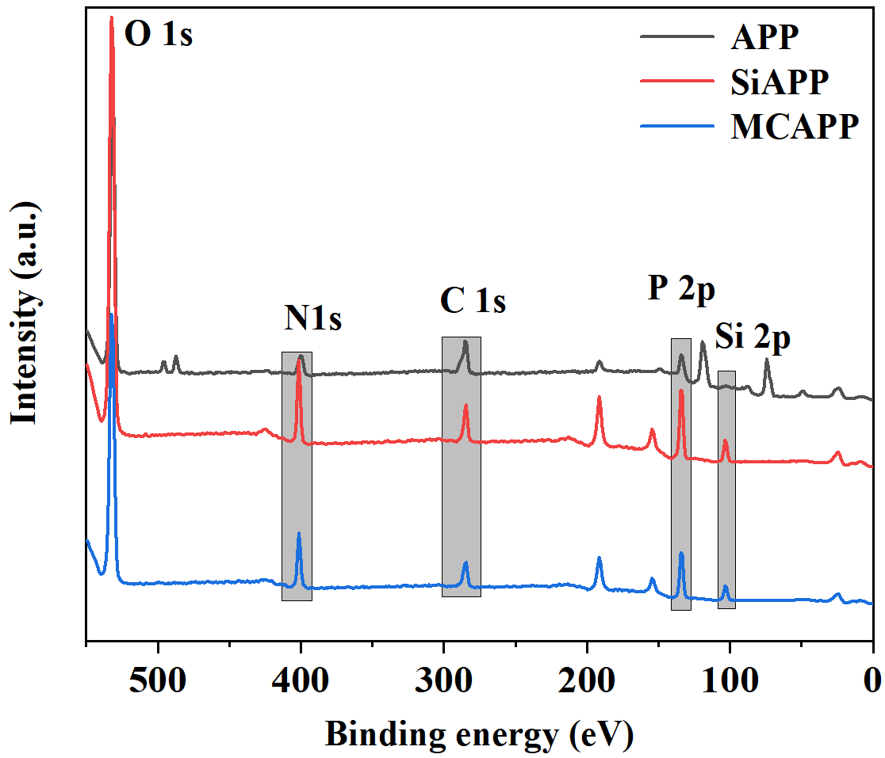

**Fig. S1** XPS spectra of APP, SiAPP, and MCAPP.

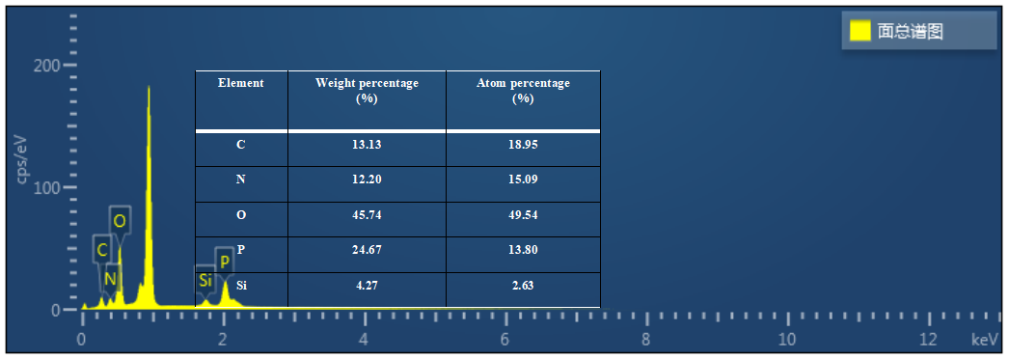

**Fig. S2** Chemical compositions of MCAPP from EDX.

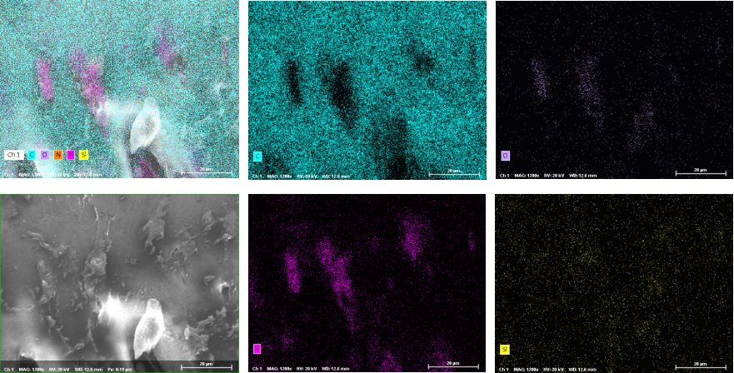

**Fig. S3**. Cross-sectional SEM mapping images of XLPE-4 composite.

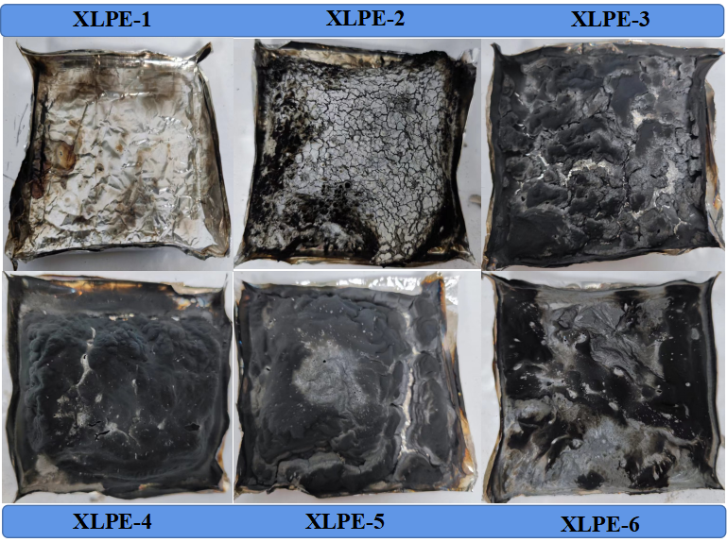

**Fig. S4.** Digital photos of char residues for XLPE composites.

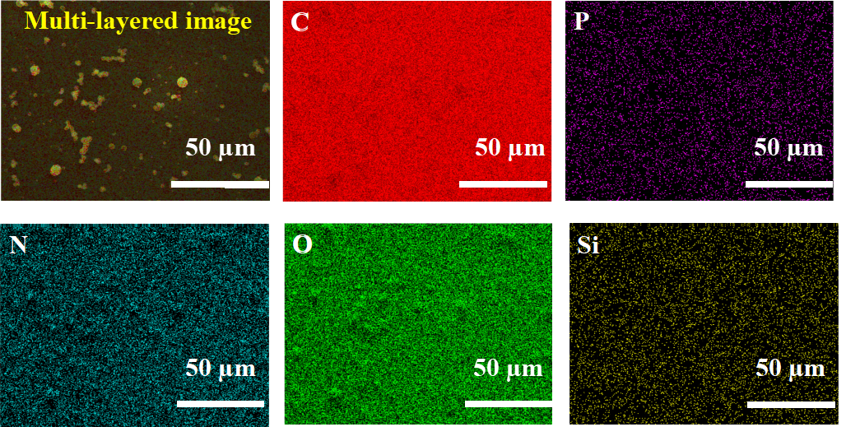

**Fig. S5**. SEM mapping image of char residue from XLPE-4 composite.

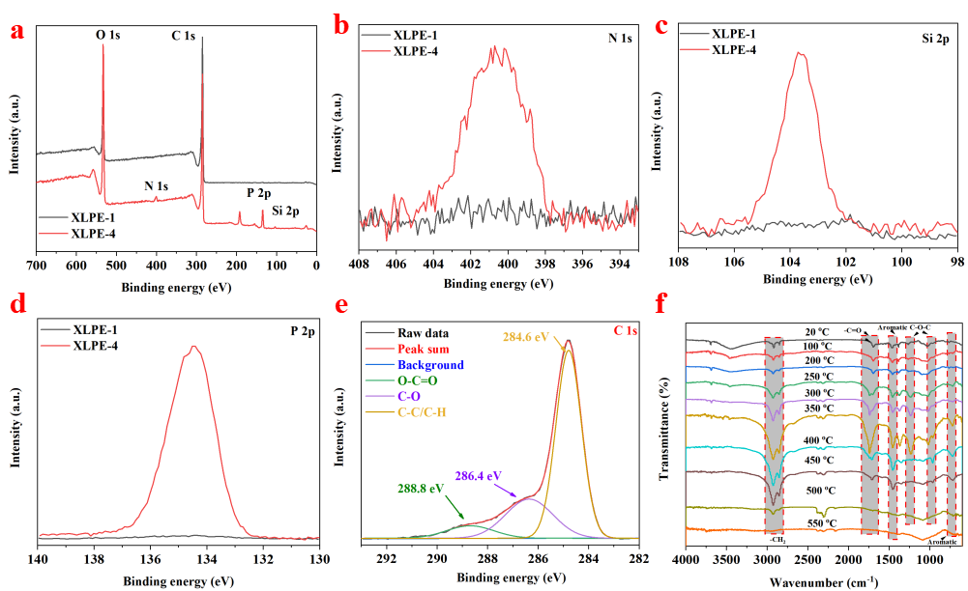

**Fig. S6.** (a) XPS survey spectra and (b−e) its high resolution XPS spectra of char residue: N 1s, Si 2p, P 2p, and C 1s. (e−f) RT-FTIR spectra of XLPE-4 at different temperatures.